Fast Sorting Algorithms on a Linear Array with a Reconfigurable Pipelined Bus System
Amitava Datta, Subbiah Soundaralakshmi and Robyn Owens
IEEE Transactions on Parallel and Distributed Systems, March 2002 (Vol. 13, No. 3) pp.212-222
Abstract
- Introduction
- Linear array with reconfigurable pipelined bus system
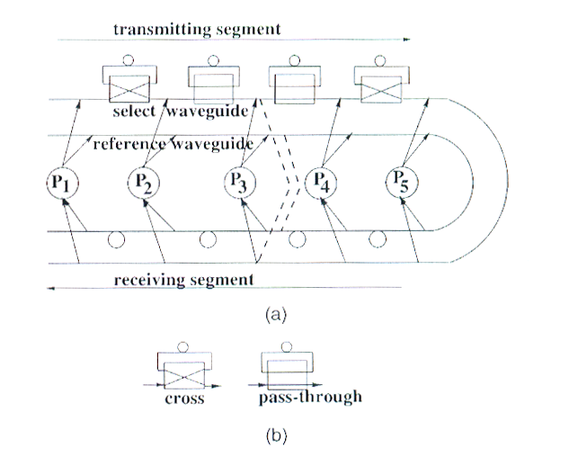
- Merging algorithm on an LARPBS

Algorithm
Input : Two sorted sequences L and R of length N each.
Output : A merged sorted sequence LR of 2N elements.

Example:
L= {1, 5, 9, 13, 17, 19, 20, 23, 26}
R= {3, 4, 11, 16, 22, 24, 27, 28, 30}

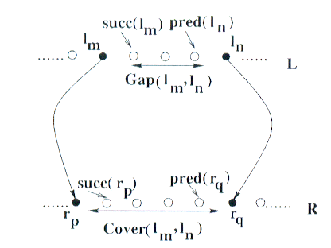

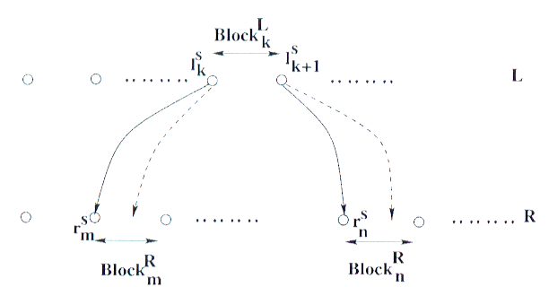

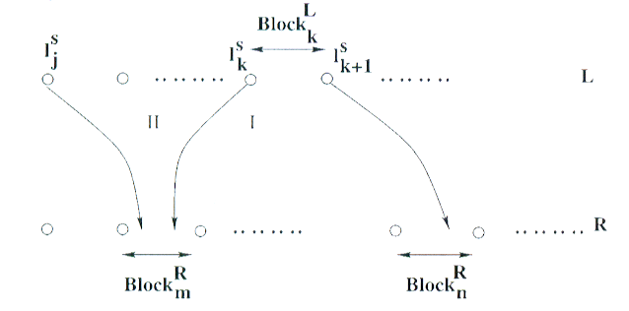

- An 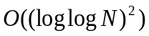 time sorting algorithm using 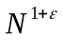 processors

Algorithm
Input : 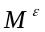 sorted sequences, each with 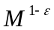 elements.
Output : A single merged sequence with M elements.

Example:
A= {1, 13, 18, 32}
B= {2, 9, 11, 22}
C= {4, 8, 10, 20}
D= {12, 14, 19, 30}

Created by : Rei-Sing Cheng
Date : Jun. 26, 2002

